**PROJECT REPORT**

*RETAIL MANAGEMENT*

1. **INTRODUCTION**
   1. **OVERVIEW**

***Retailing*** *is a process through which goods are transported to final customers. In other words, retailing consists of the activities involved in selling directly to the ultimate consumer for personal, non-business use.*

***Retail management*** *refers to the* ***process of helping customers find products in your store.*** *It includes everything from increasing your customer pool to how products are presented, and how you fulfill a customer’s needs. A good store manager helps customers leave the store with a smile.*

***1.2 PURPOSE***

*Retail management gives an easy shopping experience for the customers. Customers expect more from retailers than ever before. Retailers can offer robust benefits to serve shopper needs, retain current customers, and draw in new customers. Some of the benefits of retail management strategies are*

* + - * *Easy shopping experience*
      * *Customer engagement*
      * *Personalization*
      * *Instant gratification*
      * *Greater inventory option*
      * *Targeted discounts*
      * *Price matching*
      * *Loyalty rewards*
      * *Credit cards*

*Retail management optimizes internal processes such as inventory management, offline and online storefronts, warehouse operations, payment and accounting, and human resources. Retail management improves overall company cohesion. Retail store management improves customer experience and boosts customer satisfaction.*

**2. PROBLEM DEFINITION AND DESIGN THINKING**

**2.1 EMPATHY MAP**

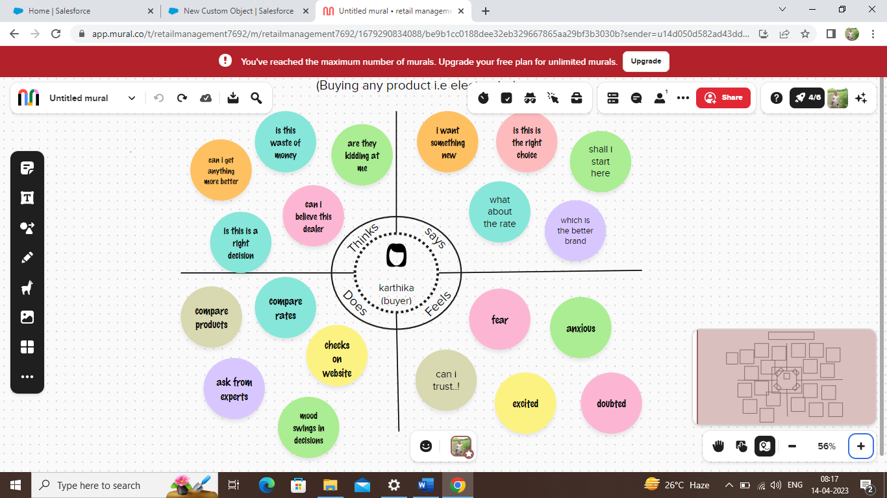

*This empathy map shows what a person i.e the buyer feels, thinks, does and says while buying a product from a retailer*

**2.2 IDEATION AND BRAINSTORMING MAP**

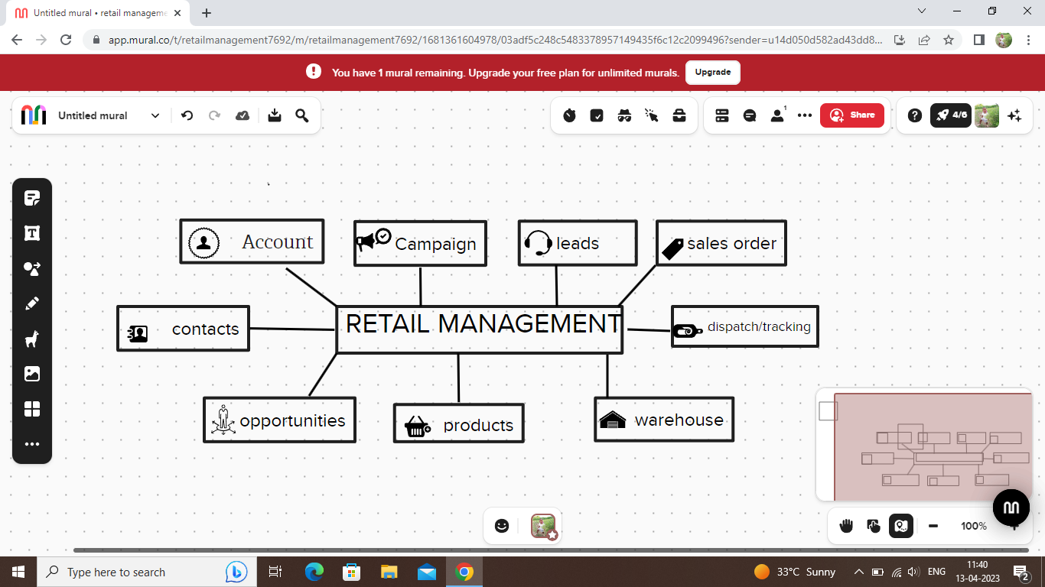

*The above map represents the objects connected with retail management.*

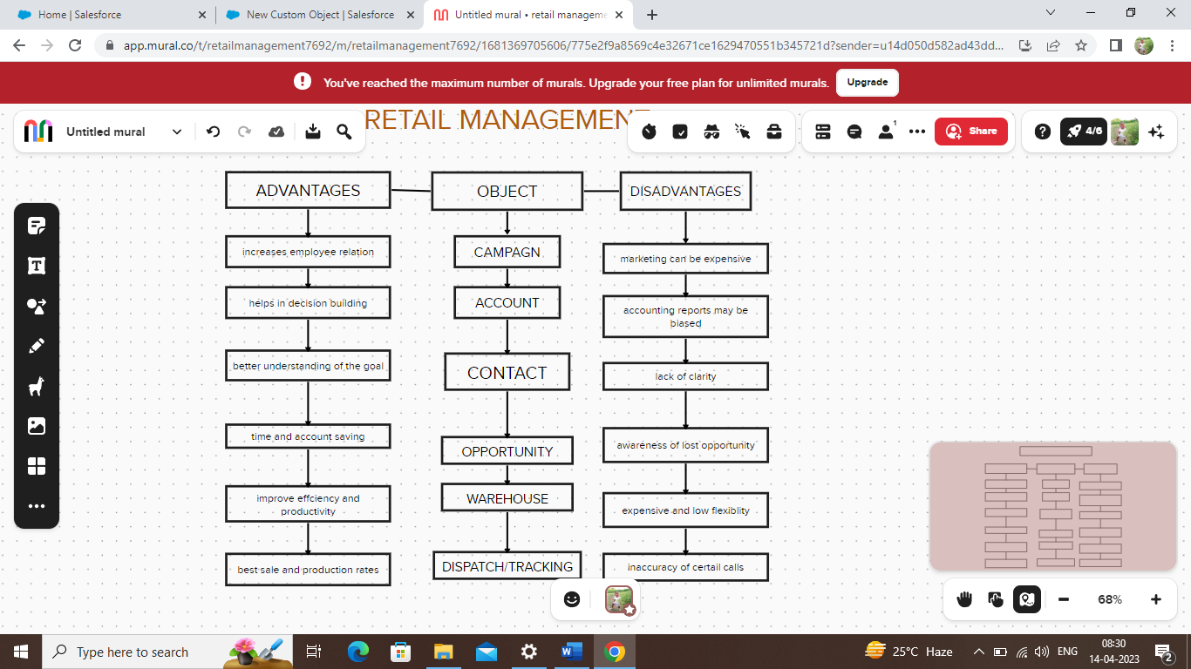

*The advantages and disadvantages of the objects concerned with retail 1*

**3. RESULT**

**3.1 DATA MODEL**

|  |  |
| --- | --- |
| **Object name** | **Fields in the object** |
| ***Campaign*** | |  |  | | --- | --- | | **Field label** | **Data type** | | campaign name | *text* | | *Type* | *picklist* | | *Sort date* | *Date* | | *End date* | *Date* | | *Expected revenue in campaign* | *Currency* | | *Budget cost in revenue* | *Currency* | | *Actual cost* | *Currency* | | *Expected response* | *Percent* | | *Parent campaign* | *text* | |
| ***Leads*** | |  |  | | --- | --- | | **Field label** | **Data type** | | *salvation* | *Picklist* | | *First name* | *text* | | *Last name* | *text* | | *company* | *Text* | | *Title* | *Text* | | *Lead source* | *picklist* | | *Annual revenue* | *Currency* | | *No of employees* | *number* | |
| ***Account*** | |  |  | | --- | --- | | **Field label** | **Data type** | | *Account name* | *Text* | | *Customer name* | *Text* | | *Account no* | *Number* | | *Phone no* | *Phone* | | *website* | *URL* | | *active* | *Picklist* | | *Annual revenue* | *Currency* | | *rating* | *Picklist* | | *dealers* | *Multi picklist* | |
| ***Contact*** | |  |  | | --- | --- | | **Field label** | **Data type** | | *Contact name* | *Text* | | *First name* | *Text* | | *Last name* | *Text* | | *Account name* | *Text* | | *Phone no* | *Number* | | *Email id* | *Email* | | *Address* | *Text* | | *Date of birth* | *Calendar* | | *Department* | *Text* | | *Lead source* | *Picklist* | |
| ***Opportunity*** | |  |  | | --- | --- | | **Field label** | **Data type** | | *Opportunity name* | *Text* | | *Account name* | *Text* | | *Type* | *Picklist* | | *Close date* | *Calendar* | | *Next step* | *Text* | | *Stage* | *Picklist* | | *Probability* | *Percent* | | *Lead source* | *Text* | |
| ***Sales order*** | |  |  | | --- | --- | | **Field label** | **Data type** | | *Sales order name* | *Text* | | *Address* | *Text* | | *Website* | *URL* | | *Sales order no* | *Number* | |
| ***Dispatch/tracking*** | |  |  | | --- | --- | | **Field label** | ***Data type*** | | *Dispatch/tracking name* | *Text* | | *Time of dispatch* | *Time* | | *Date of dispatch* | *Calendar* | | *Mode of dispatch* | *Picklist* | | *Confirmation of order* | *Picklist* | |
| ***Warehouse*** | |  |  | | --- | --- | | **Field label** | **Data type** | | *Warehouse name* | *Text* | | *Warehouse type* | *Picklist* | | *Current zone* | *Picklist* | | *Available space* | *Percent* | |
| ***Products*** | |  |  | | --- | --- | | **Field label** | **Data type** | | *Name of the product* | *Text* | | *Rate* | *Currency* | |

**3.2 ACTIVITY AND SCREENSHOT**

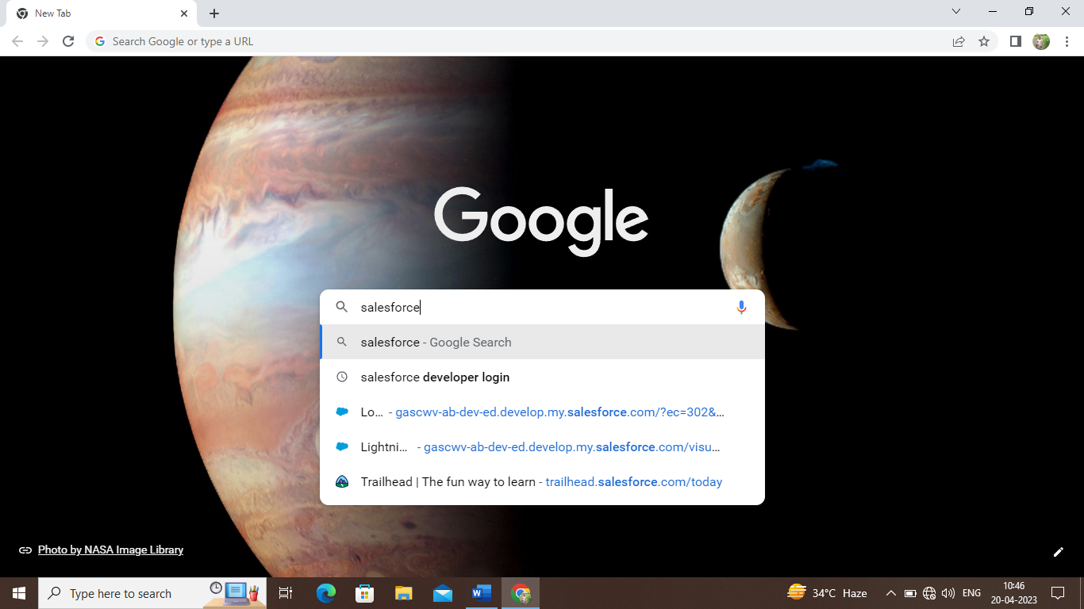

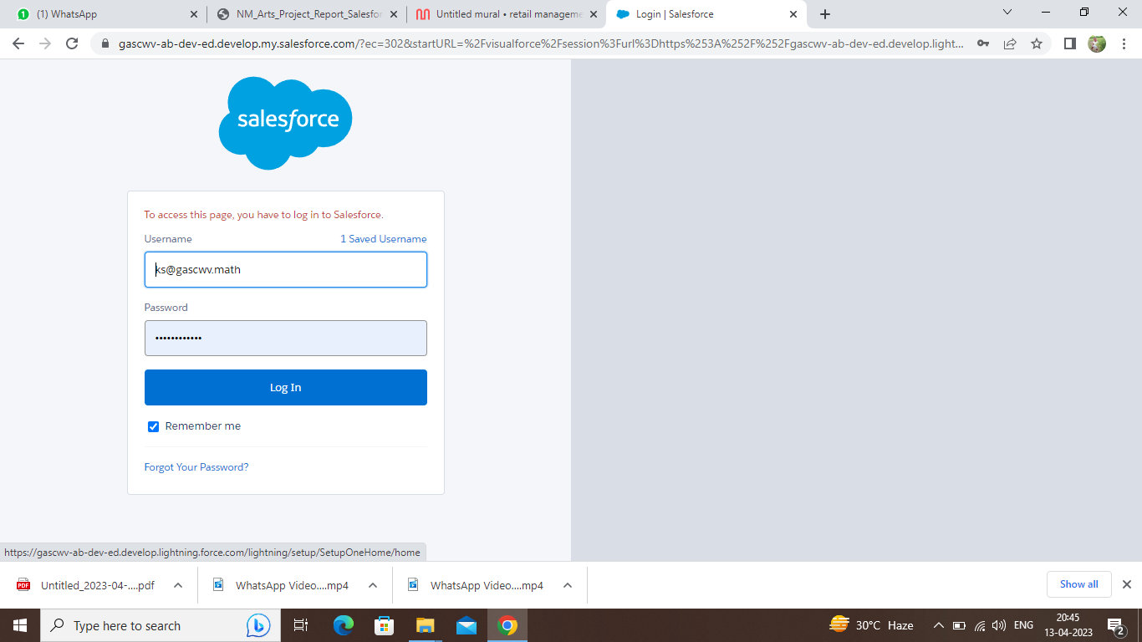

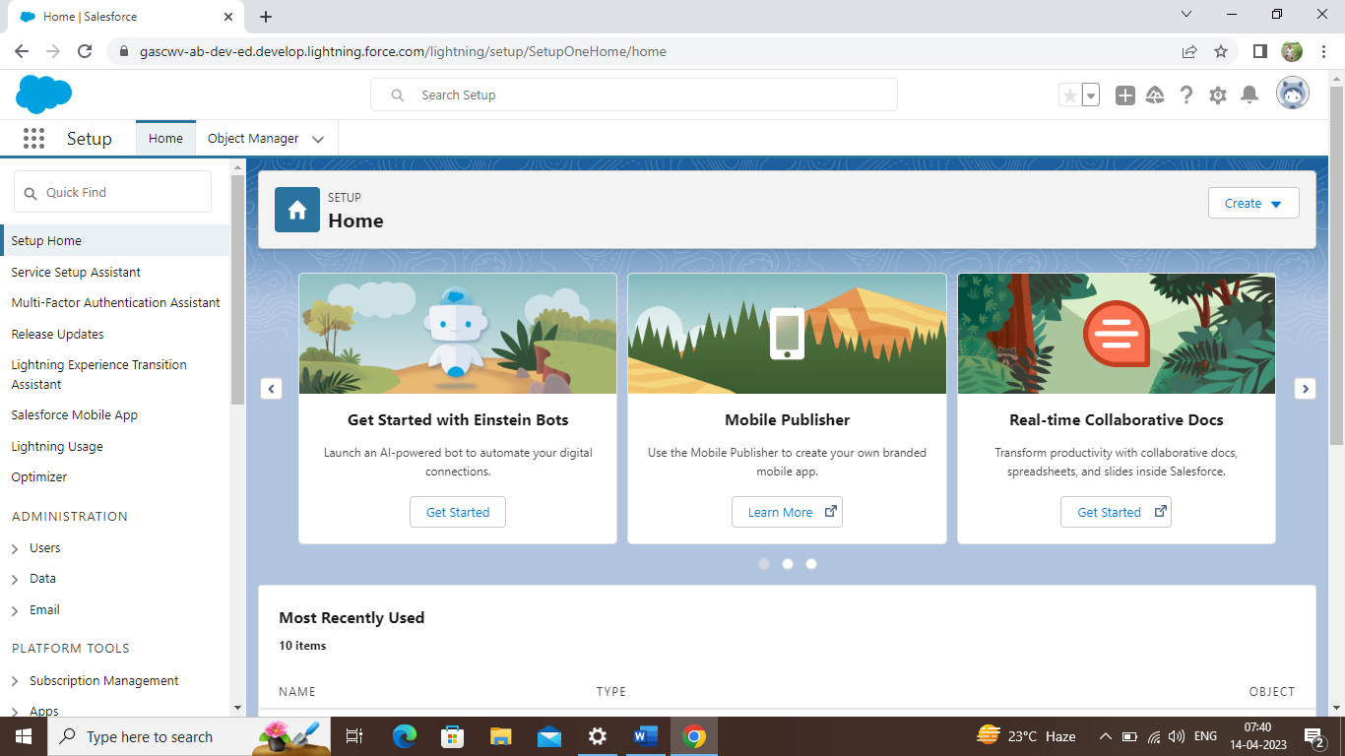

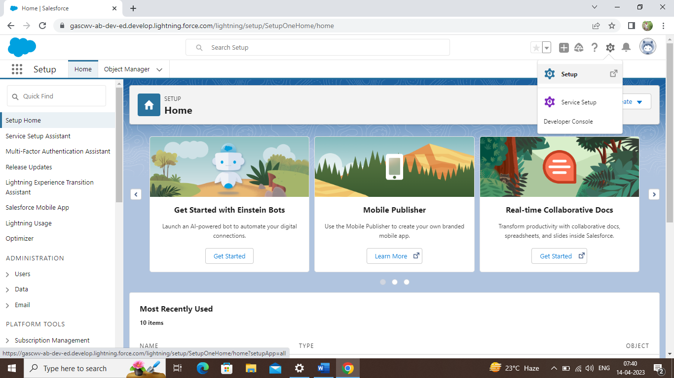

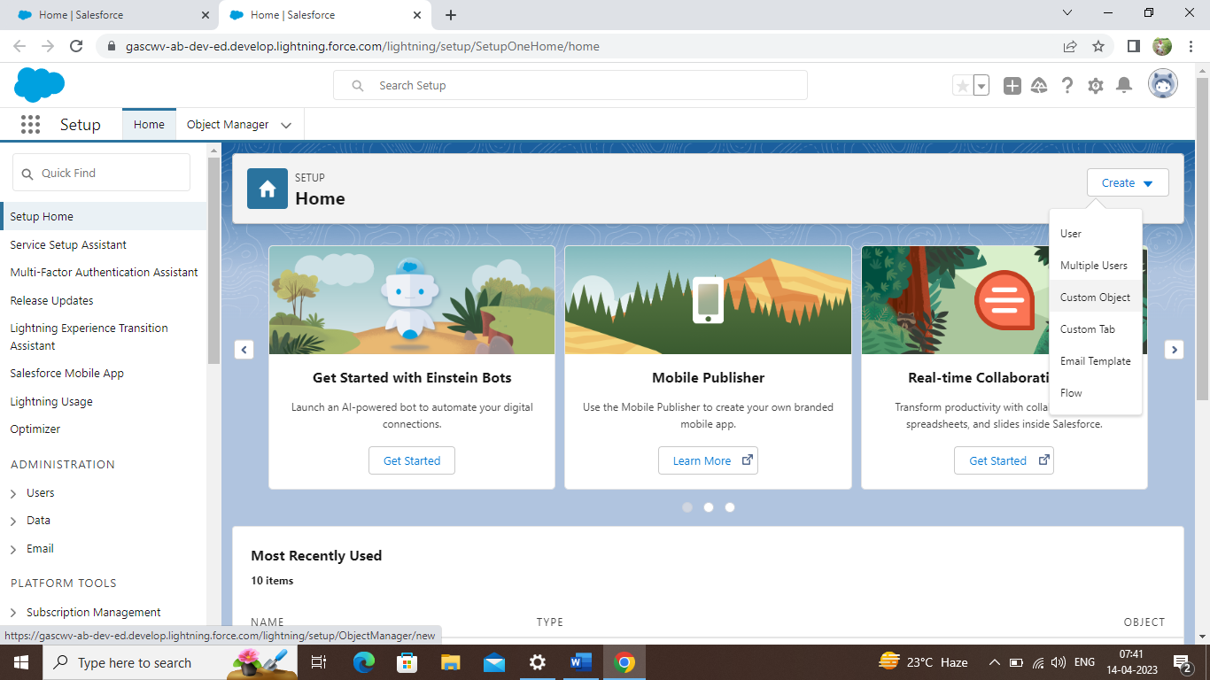

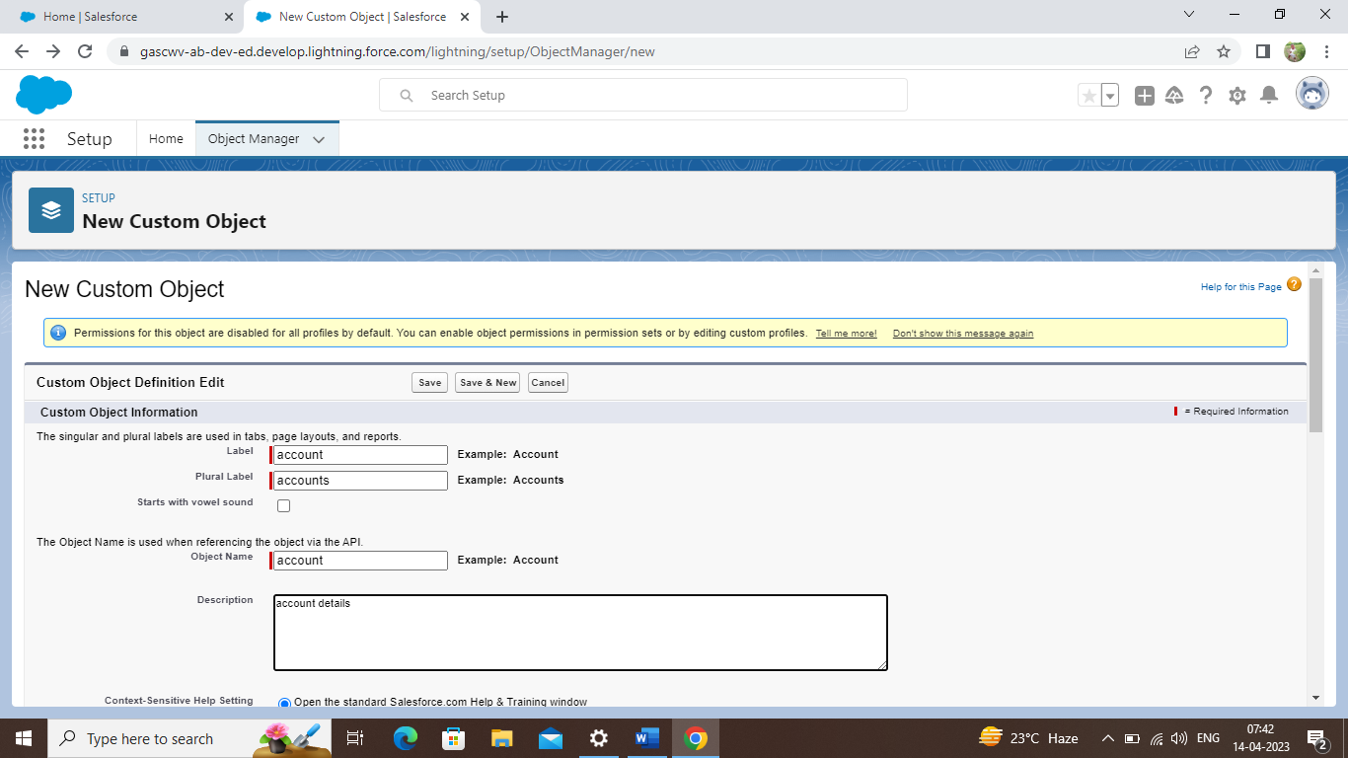

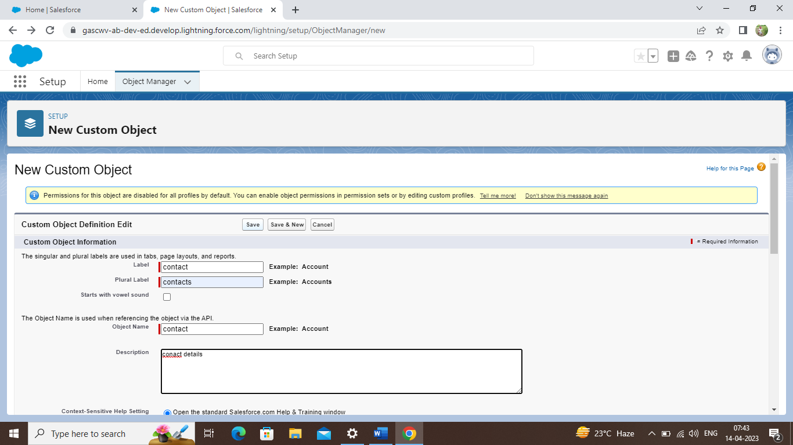

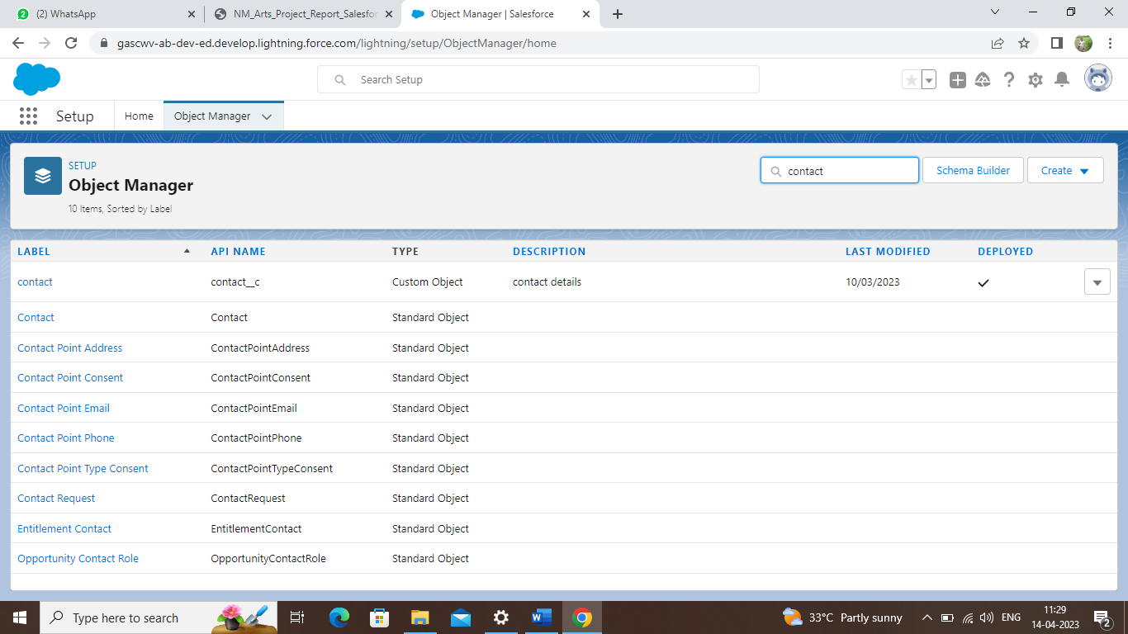

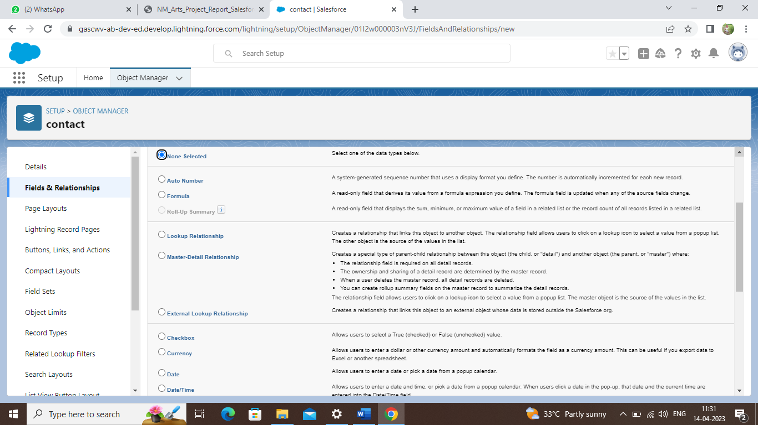

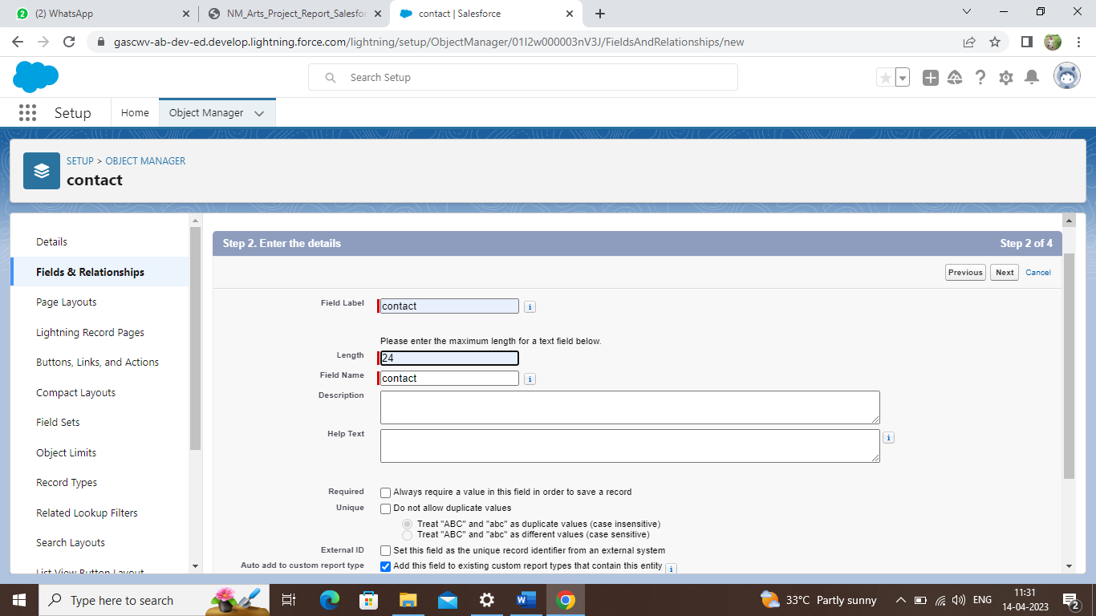

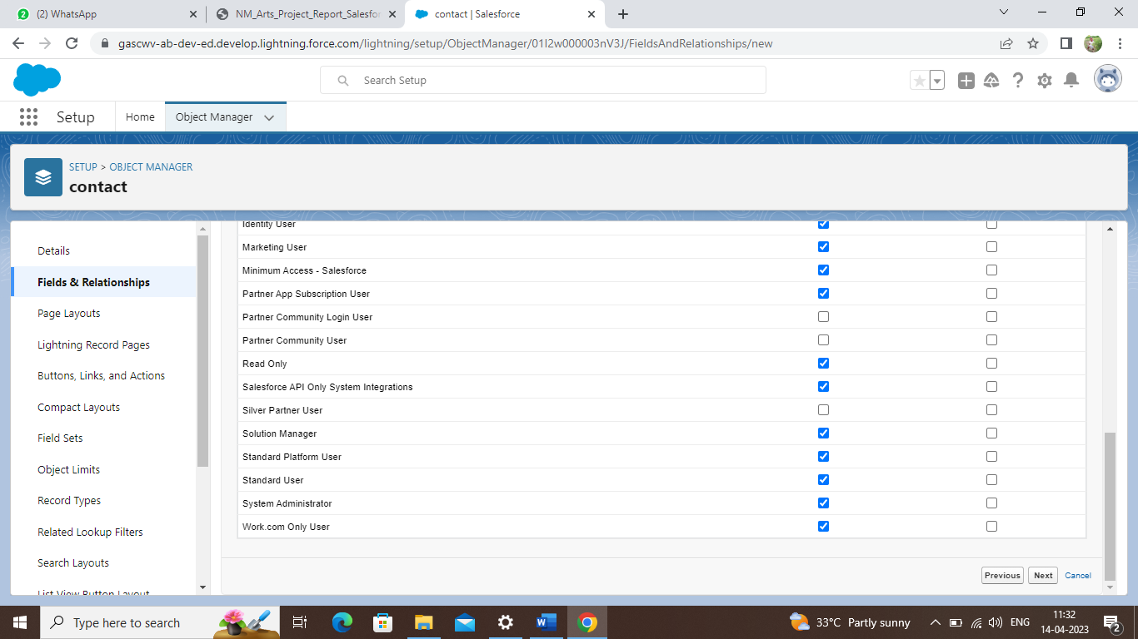

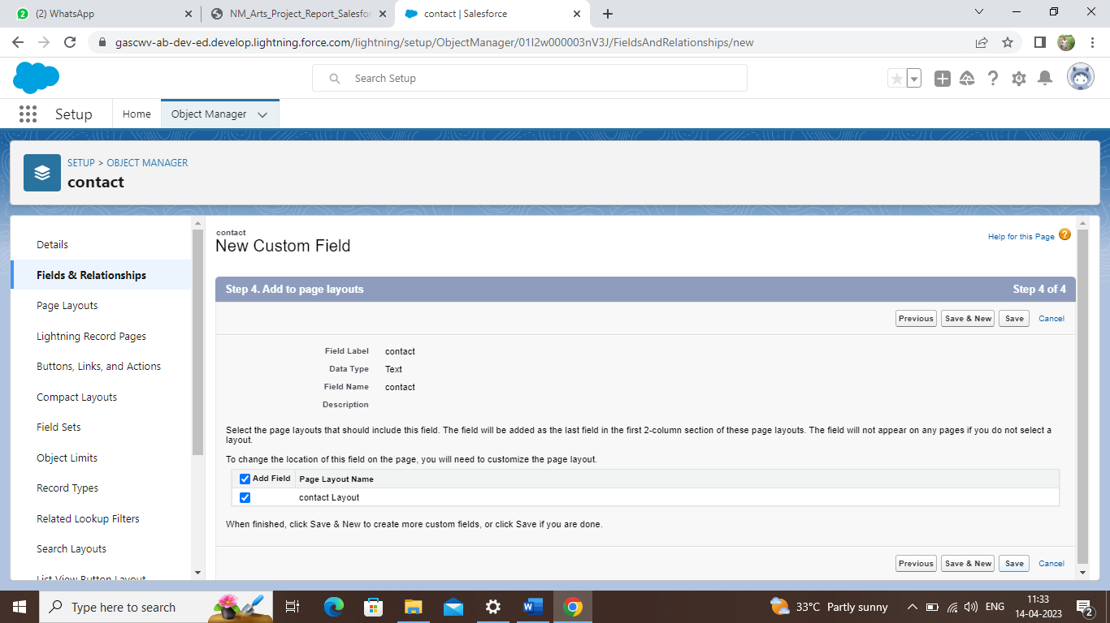

*Repeat the same procedure for all the objects and create the fields. The next step is to create an application for ‘RETAIL MANAGEMENT’.*

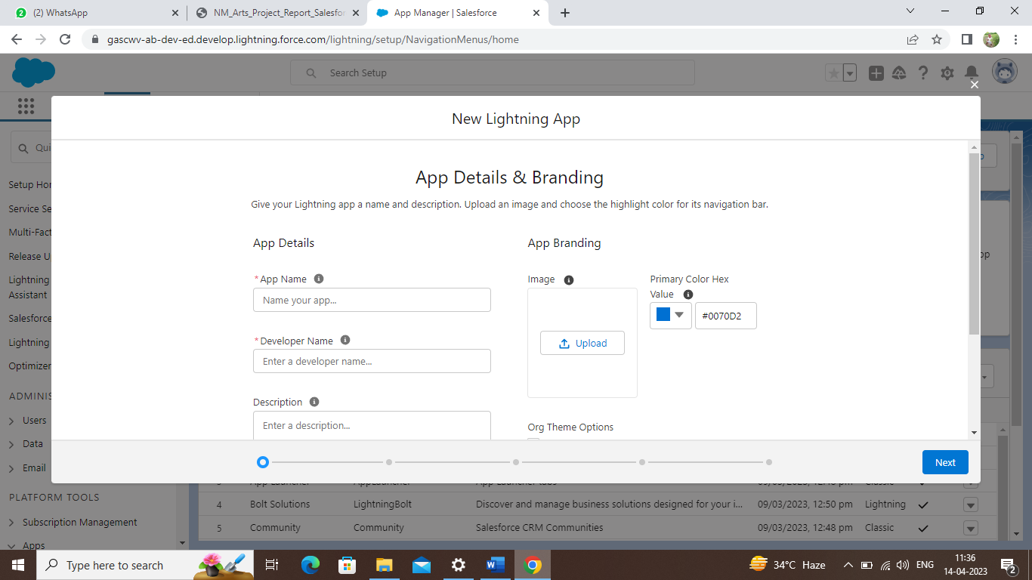

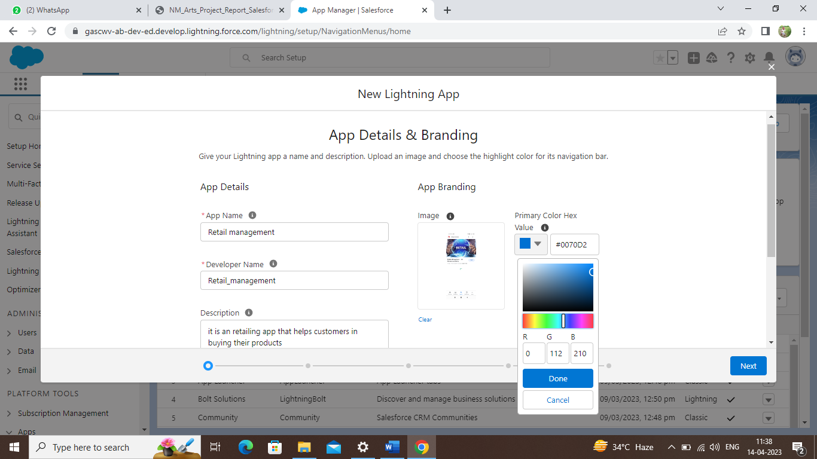

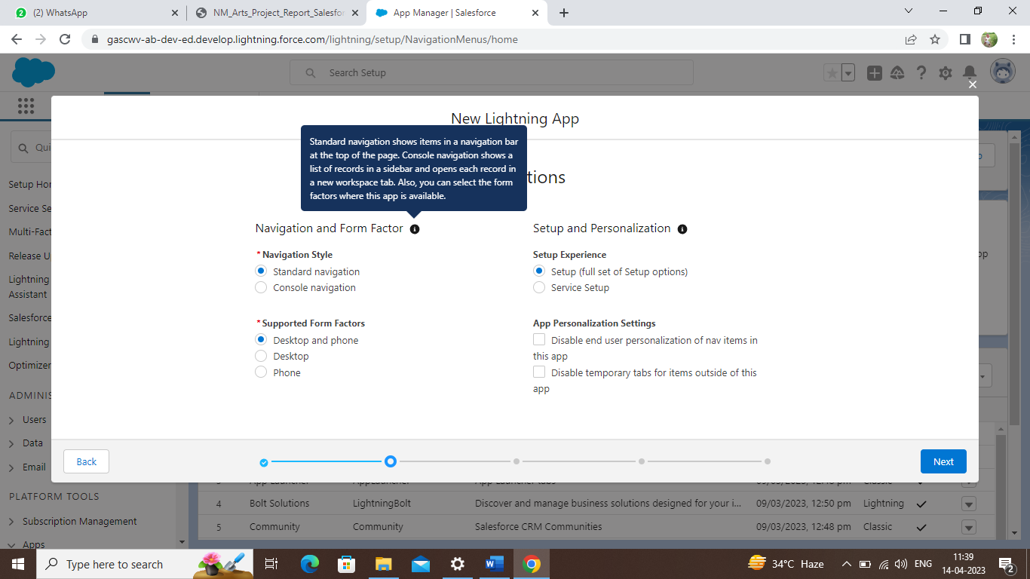

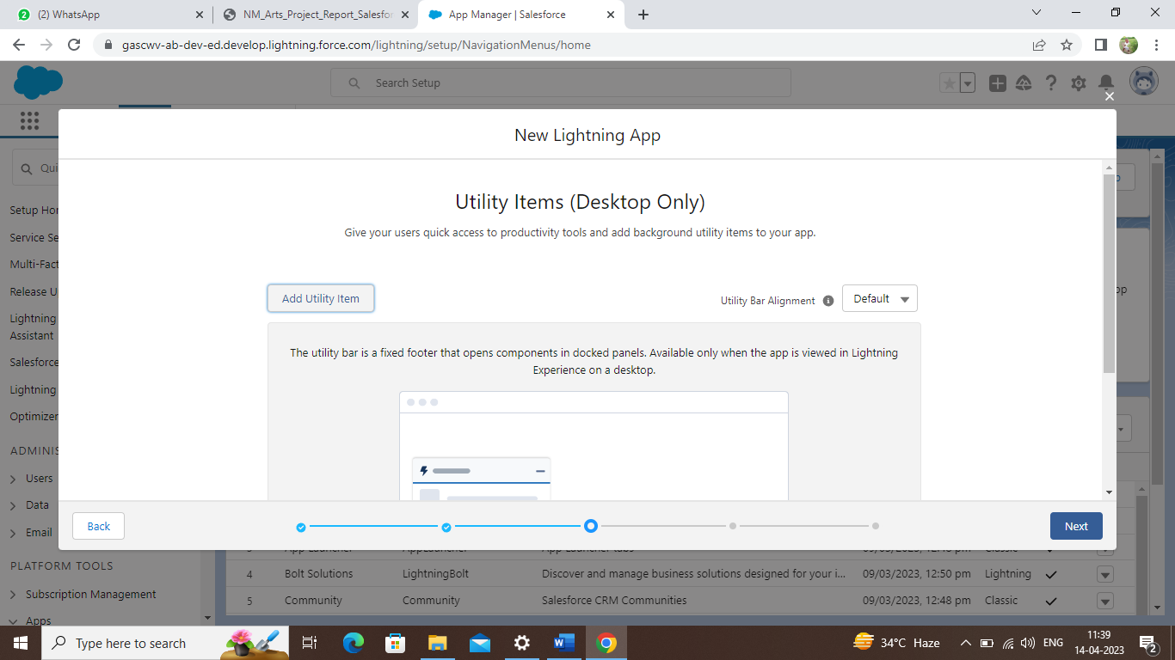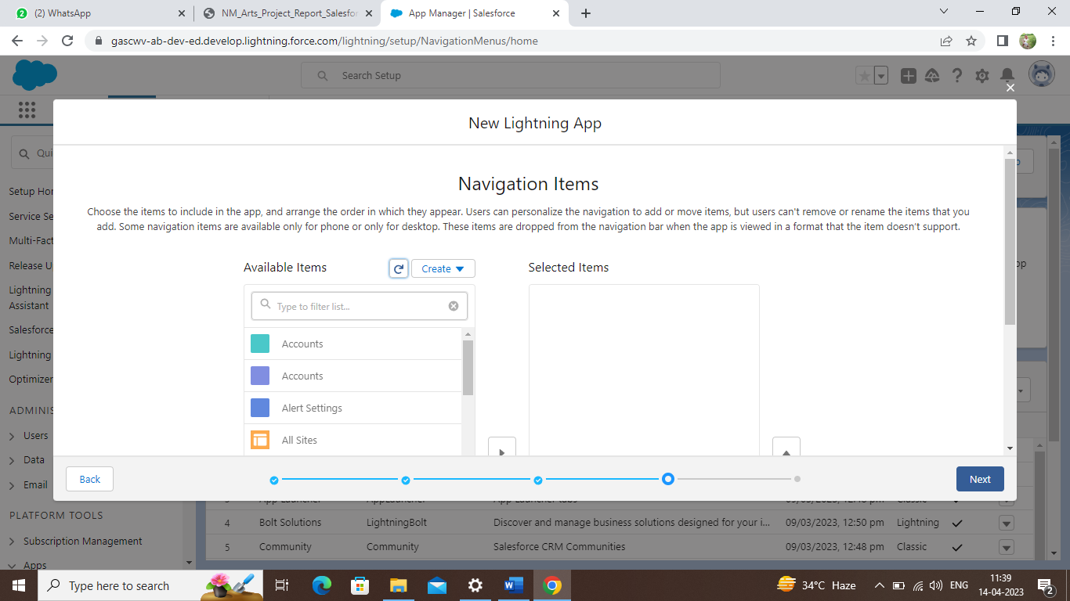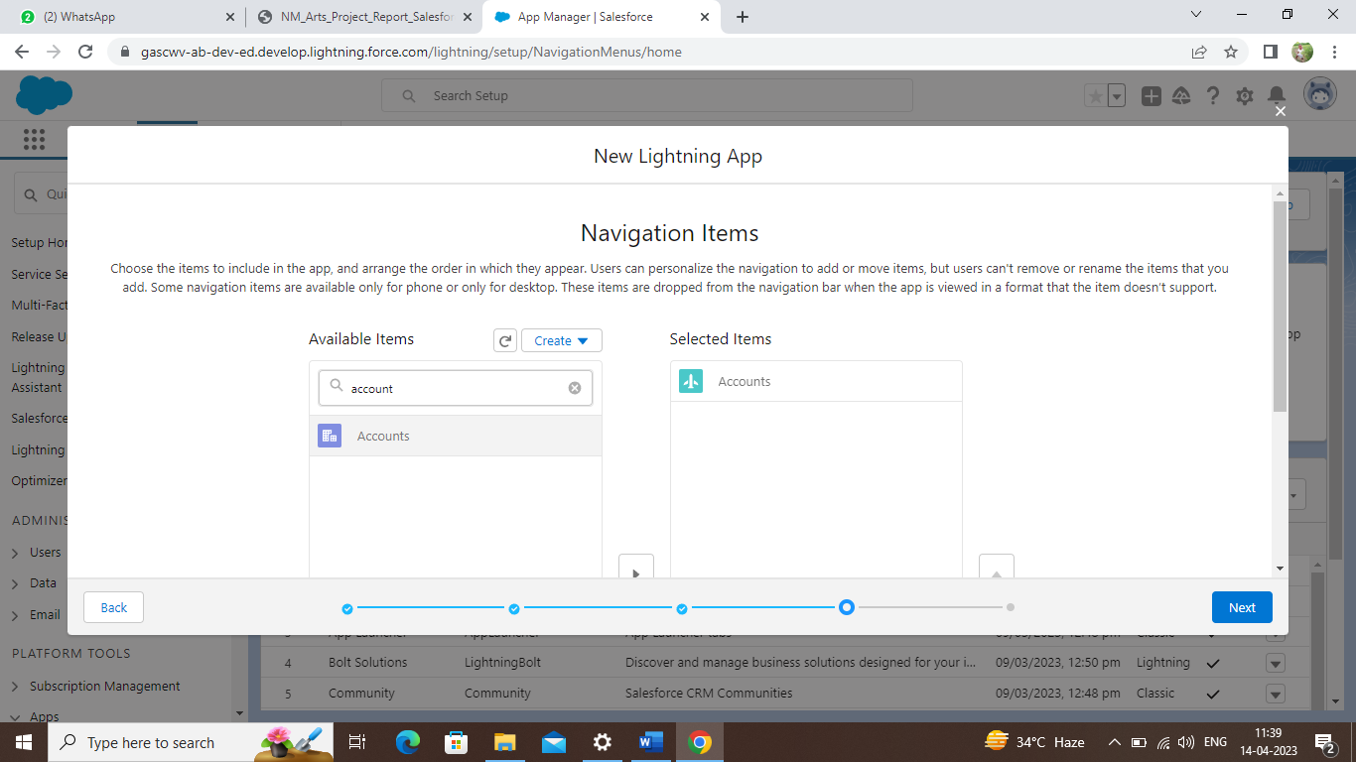

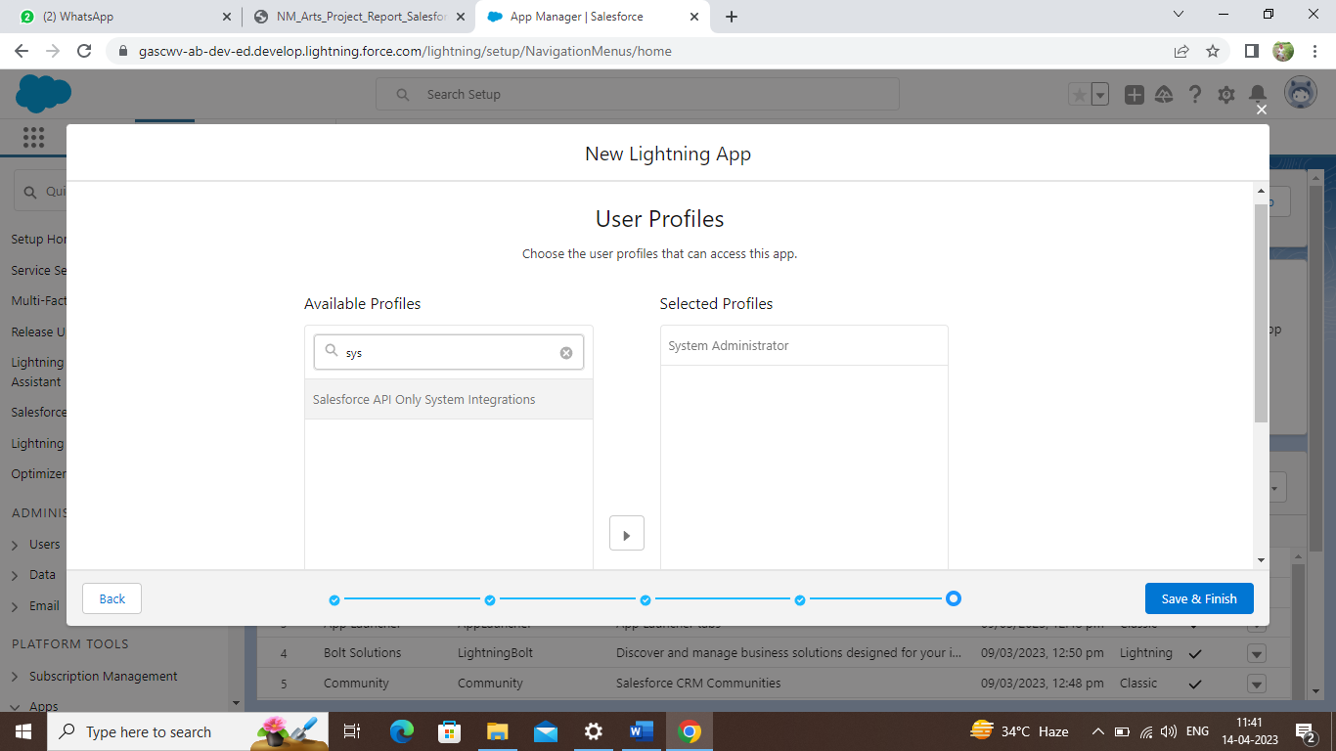

*Our application is created and we now have to add the details of our customers in the app that is created.*

*We can open our app in the* ***‘app launcher’.*** *Open app launcher and enter the name of the app that we created now. And our app will be visible. Select and open our application.*

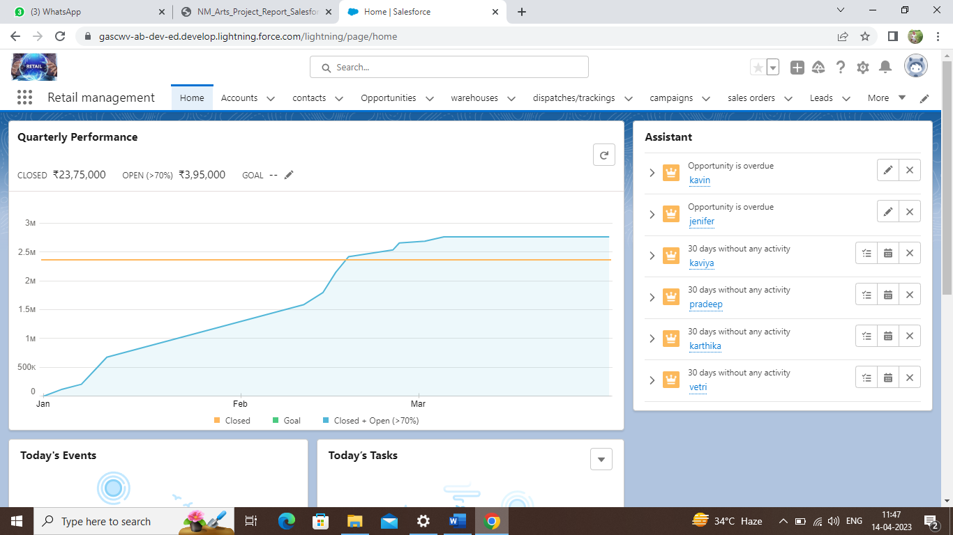

*This is the home page of the ‘RETAIL MANAGEMNENT’ app created now. now enter the details of the customers.*

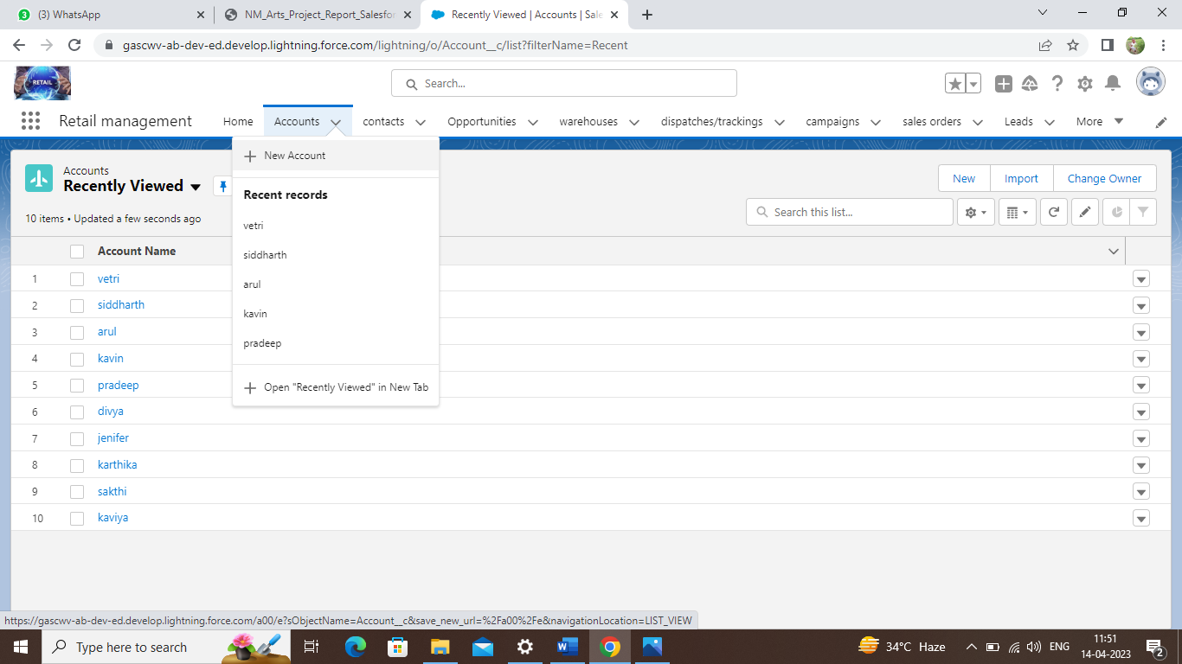

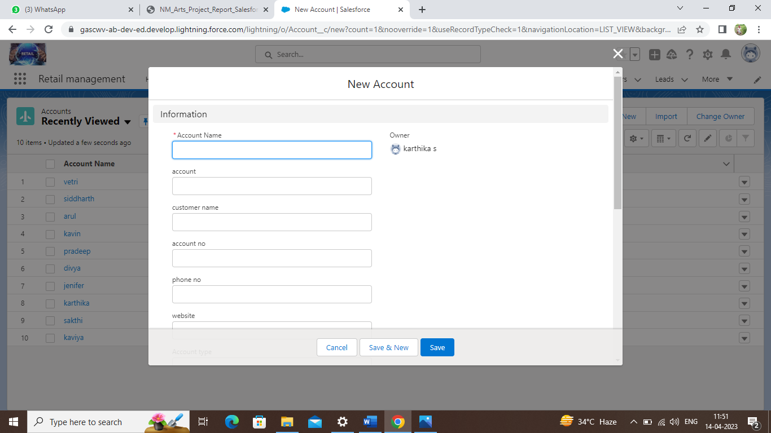

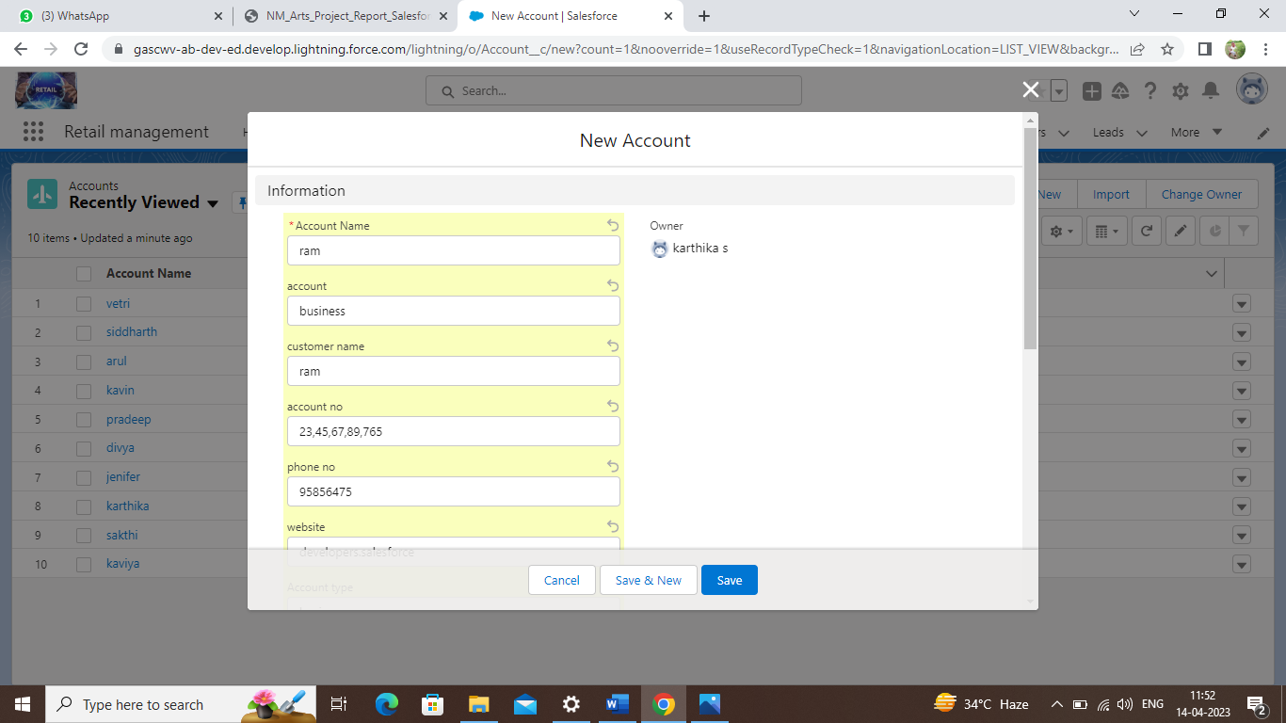

*Now we had created our app and entered the details of several of our customers. we can enter the all other details in every object in the same manner we did above. We can also add the details in various objects such as account, contacts, lead, campaign, warehouse, dispatch/tracking, sales order, product and opportunity.*

*This is the overall procedure for app creation.*

**4. TRAILHEAD PROFILE PUBLIC URL**

**Team lead -** [**https://trailblazer.me/id/manim129**](https://trailblazer.me/id/manim129)

**Team member 1 -** [**https://trailblazer.me/id/skarthikakanaga**](https://trailblazer.me/id/skarthikakanaga)

**Team member 2 -** [**https://trailblazer.me/id/deepa12345678**](https://trailblazer.me/id/deepa12345678)

**Team member 3 -** [**https://trailblazer.me/id/gomaa4**](https://trailblazer.me/id/gomaa4)

**5. ADVANTAGES AND DISADVANTAGES**

**ADVANTAGES**

1. *Optimizes all store processes: A company can increase the efficiency of each process and better ensure ahigh-quality standard for the employees. As a result, executives may accomplish goals at faster rates.*
2. *Retail is the maximum direct enterprise shape among the service provider and the purchaser. Retailing affords a facility to have face-to-face interaction. Consumers depend on stores for their wished items.*
3. *Retail income offers you extra delivery alternatives because now, no longer all commodities are to be had within the wholesale marketplace beneath each one roof. As a seller, the individual can sell the services on his phrases and might revert the clients immediately.*

**DISADVANTAGES**

1. *If you sell a variety of different items at vastly different prices, the different methods of retail accounting may not give accurate results. Another disadvantage of retail accounting is that the system can be inconsistent and only provide an estimate.*
2. *Inadequate capital is always a big problem to their trade. No room for expansion due to lack of enough capital. Inability to enjoy economies of scale.*
3. *Another challenge that will be a major concern for offline retailers will be retaining customers. A shift in the consumer spend is already being witnessed and people are cutting down on leisure shopping. In such a situation, offering loyalty solution to customers can help retailer close sales faster.*

**6. APPLICATIONS**

**RETAIL MANAGEMENT SOFTWARE** *is a technology that helps business owners drive more sales with applications that include point of sale features, inventory management, retail customer relationship management and more. these solutions often include hardware for payment terminals and can support mobile devices.*

*The major functions of retail management are:*

* *Motivating employees*
* *Developing strategies to increase the customer pool*
* *Growing store traffic*
* *Meeting sales goals*
* *Ensuring customer satisfaction*
* *Improving profitability*
* *Preventing shoplifting*

**7. CONCLUSION**

**Retail management** *is the process that refers to the process of helping customers find products in your store. In the total procedure of the retail management topic we have observed the objects necessary for the retailing process. We have learned many upcoming scopes in the retailing section.*

*The retail management had a wise scope in the future and this project helps us to understand the scope in the fore period.*

***8. FUTURE SCOPE***

*The retail sector in the country is currently booming, providing plenty of career prospects for people with a passion for*

* *Sales marketplace*
* *Business diversification*
* *Campaigning*
* *Advertising*
* *Market research*
* *Segmentation*

*With the continuous expansion of the retail industry, there is a growing demand for retail courses that will prepare students to cope with the tactics, procedures, and methods that will help them generate more sales and customer satisfaction.*

*THANKYOU*

*Project by*

**Team lead -** *M. Manimozhi*

**Team member 1 -** *S. Karthika*

**Team member 2 -** *M. Kanimozhi*

**Team member 3 -** *A. Gomathi*

*B.sc mathematics*

*Government arts and science college (women), veppur 621 717*